ADVERTISEMENT

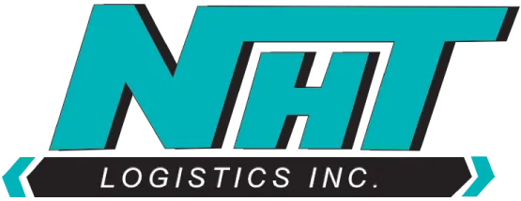
NHT Logistics, Inc., Denver, PA, is a family-owned logistics organization providing safe and reliable refrigerated and frozen transportation, temperature-controlled transportation, and cold storage refrigerated warehousing services throughout the Mid-Atlantic Region. A growing company, NHT provides complete supply chain solutions and offers customized truckload and LTL (Less Than Load) options to customers, going the extra mile to meet their needs. Known for safety and unsurpassed customer satisfaction, NHT Logistics values relationships and strives to conduct business in a God-honoring way through demonstrating the core values of integrity, stewardship, excellence, family, and eternal perspective each day. Additionally, NHT is known for a remarkable commitment to employees and their families.

NHT Logistics, Inc. is seeking to hire a full-time Director of Transportation to oversee daily transportation, dispatch, and logistical operations. The Director of Transportation will work alongside company leaders to strategically advance organizational initiatives and proactively provide exceptional customer service. Daily responsibilities include leading the Dispatch Team, scheduling, dispatching, staying current with industry regulations, advancing safety programs, and building relationships with drivers. The ideal candidate will promote and strengthen company values while demonstrating a self-motivated passion for furthering company growth.

Director of Transportation Position Qualifications:
- Minimum of five (5) years of experience in the transportation, dispatch, warehouse, or logistics industry
- At least three (3) years of successful leadership experience including managing teams and developing people
- Demonstrated business and financial acumen
- Prior our current CDL license, required
- Bachelor’s degree or continuing education, preferred
- Demonstrated proficiency with technology including Microsoft Office Suite, required; Experience with Trucking Management Software (TMS), strongly preferred
- Excellent communication skills, both written & verbal
- Demonstrated community involvement, strongly preferred

Please submit resume and cover letter: www.NorthGroupConsultants.com/jobs

